1.39: Using components as a check for any graphical method, the components of are 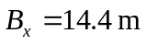and 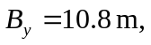has one component, 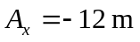.
a) The and 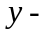components of the sum are 2.4 m and 10.8 m, for a magnitude of 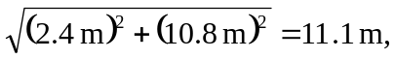, and an angle of 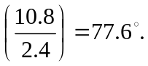
b) The magnitude and direction of A + B are the same as B + A.
c) The x- and y-components of the vector difference are – 26.4 m and 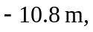for a magnitude of 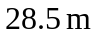and a direction arctan 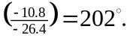 Note that 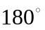must be added to 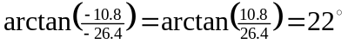 in order to give an angle in the third quadrant.

d)

